**Name: Aryaman Mishra**

**Reg. no: 19BCE1027**

**Date: 11-10-2021**

**EXPERIMENT NO: 9**

**Design of PCB for Audio Amplifier**

**Aim:** To design PCB for Audio Amplifier using EasyEDA.

**Software used:** EasyEDA

**Components used:**

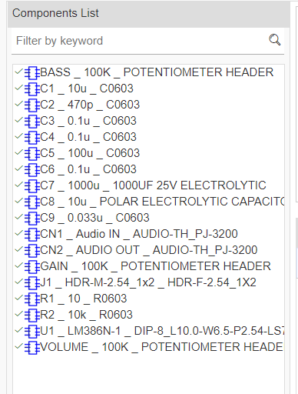

**Circuit:**

**Audio Amplifier:**

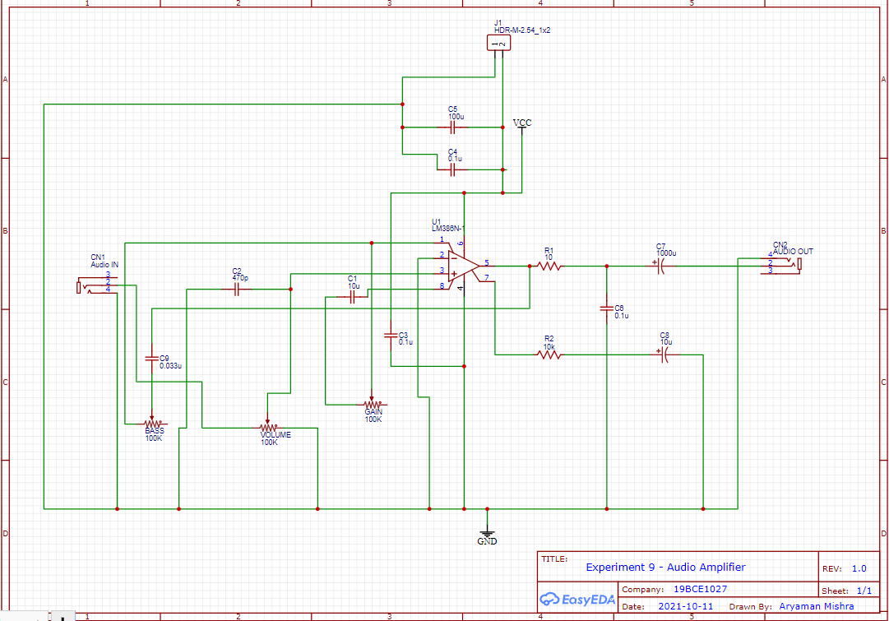

**PCB Circuits:**

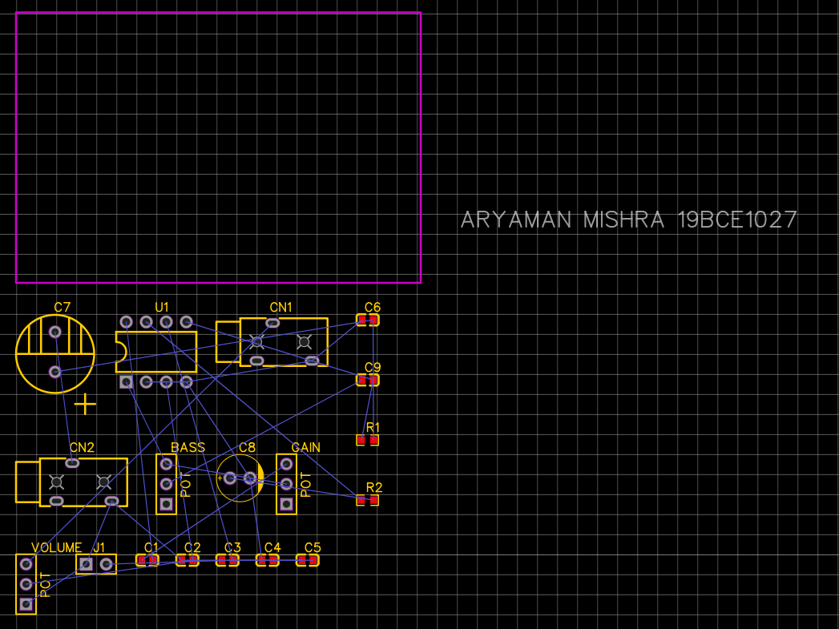

**Arrangement:**

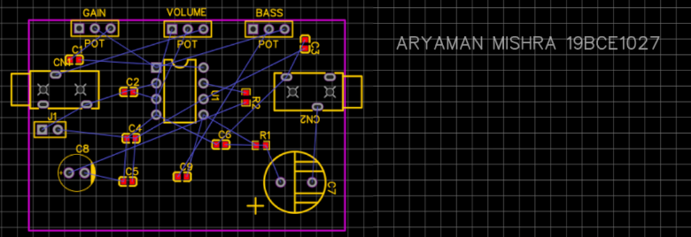

**After auto routing:**

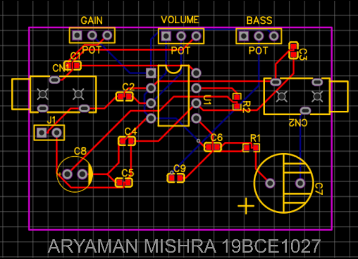

**PCB of Audio Amplifier:**

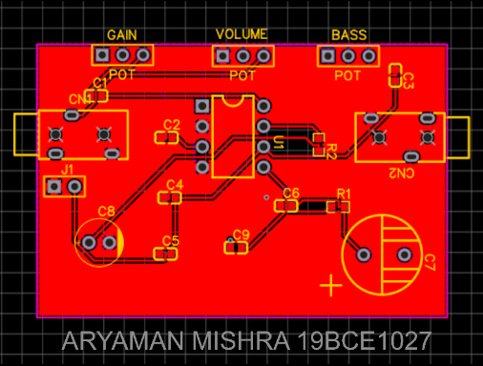

**Conclusion:**

In the PCB circuit of a Audio Amplifier CN1 and CN2 are audio in and audio out jacks, C7 is 25V electrolytic capacitor and C8 is polar electrolytic capacitor, R1 and R2 are the resistors, J1 is connector, GAIN, VOLUME, and BASS are potentiometer headers and U1 is LM386N-1 audio amplifier and the red color shows the copper area usually referred as GND.

Thus, we successfully designed a PCB for Audio Amplifier using EasyEDA tool.